Business Requests

1.Provide a list of products with a base price greater than 500 and that are featured in promo type of 'BOGOF' (Buy One Get One Free). This information will help us identify high-value products that are currently being heavily discounted, which can be useful for evaluating our pricing and promotion strategies."
SQL:
select distinct(dim_products.product_name), A.base_price, A.promo_type from dim_products join fact_events as A ON dim_products.product_code= A.product_code
where base_price>=500 and promo_type="BOGOF";
Ans:
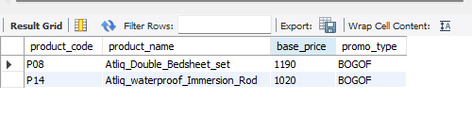
2. Generate a report that provides an overview of the number of stores in each city. The results will be sorted in descending order of store counts, allowing us to identify the cities with the highest store presence. The report includes two essential fields: city and store count, which will assist in optimizing our retail operations."
SQL:
select city, count(store_id) as Total_stores from dim_stores group by city order by Total_stores desc;
Ans:
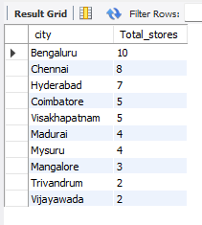
3. "Generate a report that displays each campaign along with the total revenue generated before and after the campaign? The report includes three key fields: campaign_name, total_revenue(before_promotion), total_revenue(after_promotion). This report should help in evaluating the financial impact of our promotional campaigns. (Display the values in millions)"
SQL:
select campaign_name,
ROUND(SUM(base_price* `quantity_sold(before_promo)`)/1000000,2) as Total_revenue_Before_Promotions,
ROUND(SUM(Case
WHEN promo_type = '25% OFF' THEN base_price * 0.75 * `quantity_sold(after_promo)`
When promo_type = '33% OFF' THEN base_price * 0.67 * `quantity_sold(after_promo)`
WHEN promo_type = '50% OFF' THEN base_price * 0.5 * `quantity_sold(after_promo)`
WHEN promo_type = '500 Cashback' THEN (base_price -500) * `quantity_sold(after_promo)`
WHEN promo_type = 'BOGOF' THEN base_price *ROUND(`quantity_sold(after_promo)` / 2, 0) END) / 1000000,2) AS Total_revenue_After_promotion

from fact_events
JOIN
dim_campaigns USING(campaign_id)
GROUP BY campaign_name;
ANS:
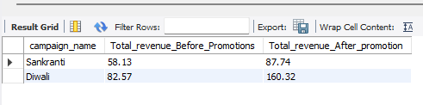

4. Produce a report that calculates the Incremental Sold Quantity (ISU%) for each category during the Diwali campaign. Additionally, provide rankings for the categories based on their ISU%. The report will include three key fields: category, isu%, and rank order. This information will assist in assessing the category-wise success and impact of the Diwali campaign on incremental sales.
Note: ISU% (Incremental Sold Quantity Percentage) is calculated as the percentage increase/decrease in quantity sold (after promo) compared to quantity sold (before promo)
SQL:
with diwali_sale as (Select category, ROUND(SUM(`quantity_sold(after_promo)`-`quantity_sold(before_promo)`)*100/SUM(`quantity_sold(before_promo)`),2) AS 'ISU%'
from fact_events A JOIN dim_products P
ON A.product_code=P.product_code
JOIN dim_campaigns C
ON A.campaign_id=C.campaign_id
where campaign_name='Diwali'
GROUP BY category)
select category,`ISU%`, row_number() over(order by `ISU%` desc) as Rank_order
from diwali_sale;
ANS:
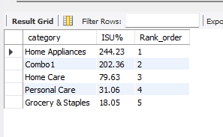
5. Create a report featuring the Top 5 products, ranked by Incremental Revenue Percentage (IR%), across all campaigns. The report will provide essential information including product name, category, and ir%. This analysis helps identify the most successful products in terms of incremental revenue across our campaigns, assisting in product optimization.
SQL:
select product_name,
category,
ROUND((SUM(Case
WHEN promo_type = '25% OFF' THEN base_price * 0.75 * `quantity_sold(after_promo)`
When promo_type = '33% OFF' THEN base_price * 0.67 * `quantity_sold(after_promo)`
WHEN promo_type = '50% OFF' THEN base_price * 0.5 * `quantity_sold(after_promo)`
WHEN promo_type = '500 Cashback' THEN (base_price -500) * `quantity_sold(after_promo)`
WHEN promo_type = 'BOGOF' THEN base_price *ROUND(`quantity_sold(after_promo)` / 2, 0) END)
-SUM(base_price* `quantity_sold(before_promo)`))/SUM(base_price* `quantity_sold(before_promo)`)*100,2) as 'IR%'
from fact_events
JOIN
dim_products USING(product_code)
GROUP BY product_name, category
ORDER By `IR%` DESC
limit 5;
ANS:
